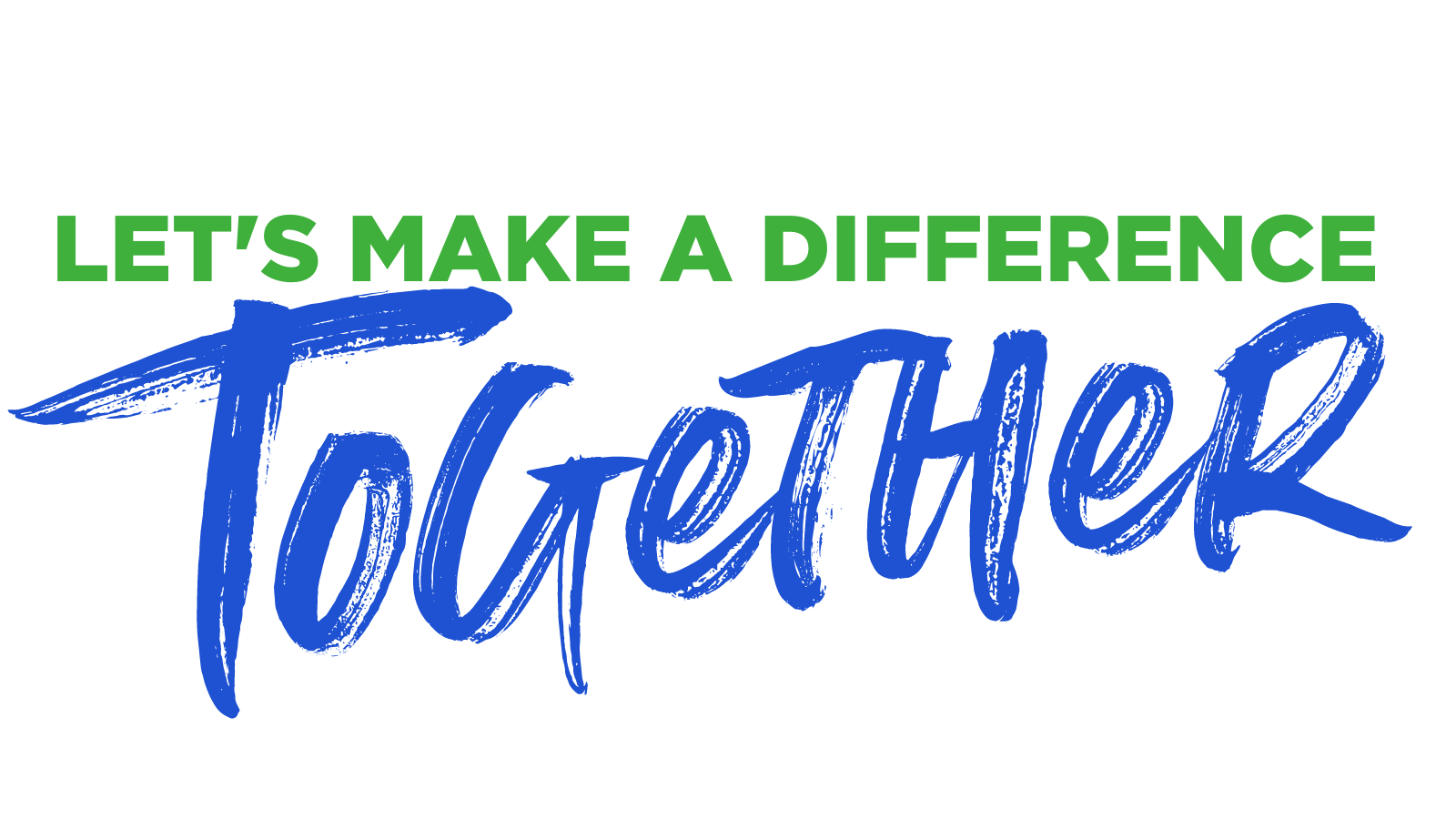

Dear Friend,

As you may know, I serve as a member of the Board of Directors for the National Runaway Safeline (NRS). NRS works to ensure this country's young people are safe and off the streets. We serve as a lifeline for any young person, 12-21 years old, who needs us, 24 hours a day, 7 days a week. And we have seen firsthand how the global pandemic has affected the thousands of youth and families we’ve served over the past year.

I am so excited to invite you to join me in supporting this amazing organization through our “Let’s Make a Difference Together” series of events. No worries, these are Covid-19 ‘stay safe and stay healthy’ approved. The “Let’s Make a Difference Together” packages include:

- A Valentine’s-themed pizza night from Lou Malnati’s, accompanied by a documentary screening and a live, virtual Q&A session with the film’s producer;

- A Journeyman Distillery whiskey flight and live (virtual) tasting with a mixologist; and

- A massive cook-at-home BBQ kit from Gibson’s Bar & Steakhouse.

Each package can be purchased individually for $200 or purchase all three, offered at a discount for $525. Prices include shipping throughout the U.S., so no need to be local to Chicago! Enjoy some of Chicago’s finest food and drinks delivered right to your door each month, or share the love with friends near and far. We have made it super easy to support a great cause, while also supporting local businesses.

Please visit www.1800runaway.org/makeadifference for more details and to purchase your packages today! The deadline to purchase the entire package is February 4, 2021, so check out the site soon. I am also happy to share more about NRS and the work that we do with you, or to connect you with NRS team members if they can better support your questions.

Thank you so much for helping to end youth homelessness.

With warm regards,

